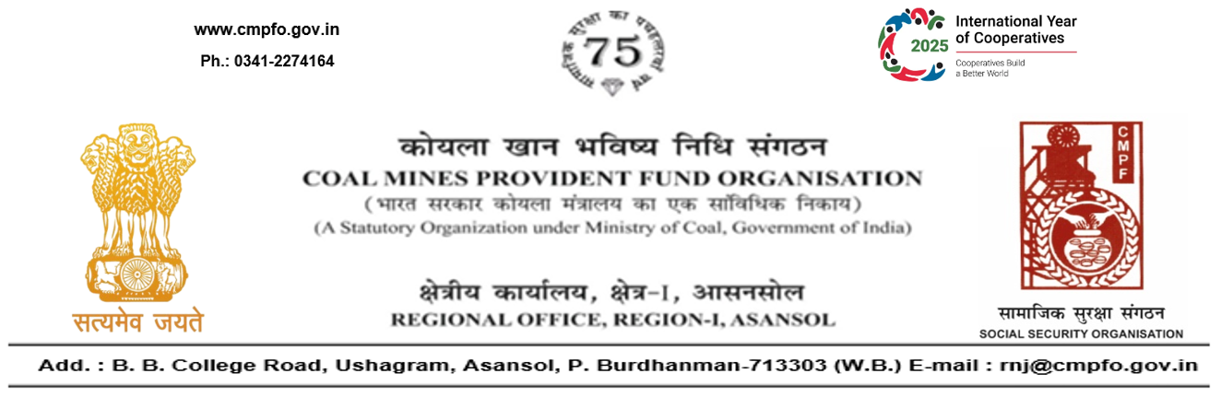
CPF/118/Misc/Ext.out./R-1/ASN/ Date:01-01-2026
To,
The Assistant Commissioner
Office of the Assistant Commissioner
Coal Mines Provident Fund Organisation
Sonali Building, Court More, VIP Chowk,
Deoghar-814112
(Jharkhand)

Sub- Supply of Extract of "VV" statement

Ref:- Your office letter no. CPF/155/Extract/DGR/6/1520 dated29/10/2025.

Sir,
With reference to your letter cited abave, it is to infrom you that L.C. is not available in this region (RNJ/21,RNJ/24) report of concerned dealing assistant is enclosed herewith for ready reference.

Yours faithfully,

(Ajay Kumar Singh)
Encl- As above Regional Commissioner - I

